Final Report

Xiao, Yafu Ai, Liyi

Department name, Institution name

ECE110: Introduction of Electronics

Li, Si

December 28, 2023

Final Report

**The Realization of a Pure Analog-Signal Controlled Rail-tracing Automatic car**

## Introduction

There are cases in life where we have to deliver goods in small amounts to somewhere that’s not so reachable to us human being. This is the place for robot cars to show their talent. We can create robots that could followed the lead of a rail and avoid crushing into possible obstacles like animals to deliver goods. This is how we came up with the idea of creating the robot as shown in our hands. So, in our final lab assignment, we created a car that can follow the black line, and meet obstacles can automatically brake to ensure safety.

The ultrasonic module and tracking module, as shown in the figure below.

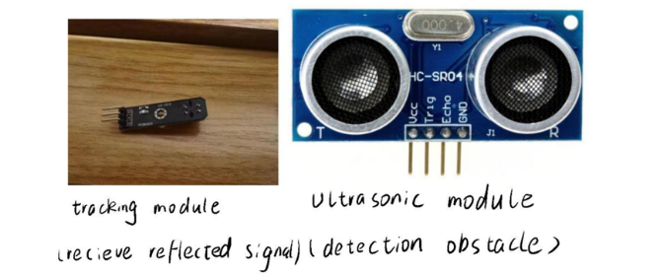

***Figure 1***, Ultrasonic Module and Tracking Module, left taken by Xiao, Yafu, right from microcontrollerelectronics.com, notes by Ai, Liyi.

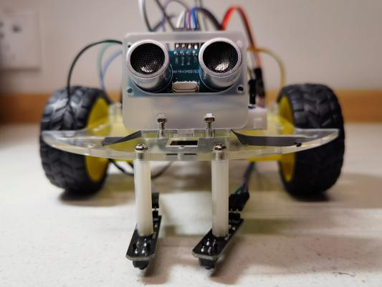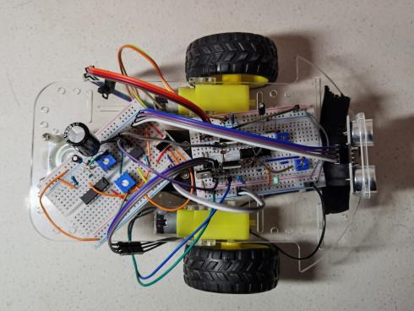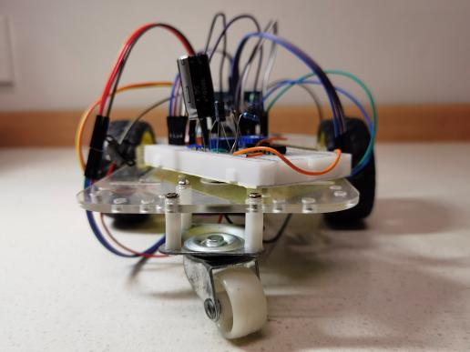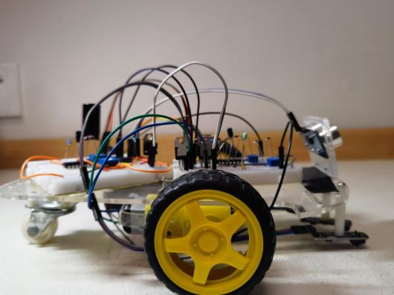

***Figure 2***, General Look of the Car, all four picture taken by Xiao, Yafu.

## Analysis of Components

### Main Components

Our main components are divided into 3 parts, Linear Voltage Regulator IC L7805CV

Rail Tracer CK-019, Ultrasonic Sensor HC-SR04

**Linear Voltage Regulator IC L7805CV.**This regulator is used to lower the voltage of the batteries, which is 7.6V to 5V, the appropriate operating voltage of most sensors on our car. Part of its datasheet is shown here.

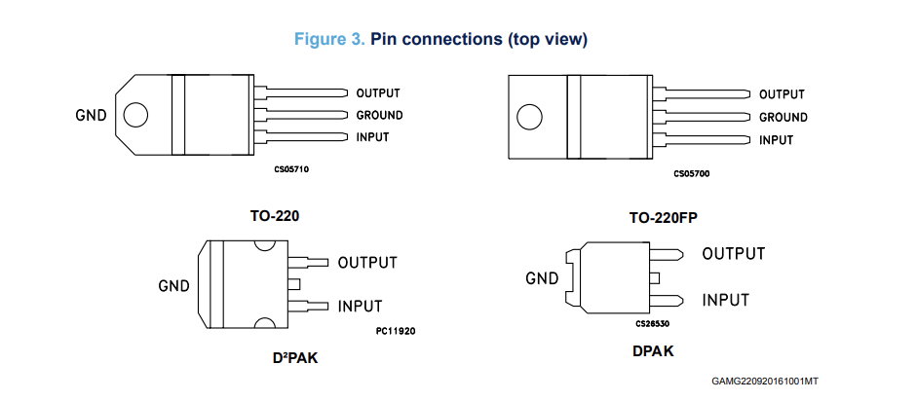

***Figure 3***, Part of the Datasheet of L7805CV, taken from st.com, accessed December 27, 2023

With this device, we can easily protect our sensors and keep the components of our vehicle running properly.

**Rail Tracer CK-019.**This module as shown in figure 4 is the older version of the rail tracer, whose output is 1 while detecting white and 0 while detecting black. The operating voltage of it is strictly restricted between 3.3 to 5V, which forced the use of L7805 to lower the battery voltage, which is 7.6V as measured on our car.

We add tracking module in the circuit and gate to control the operation of the motor, so as to achieve the function of the car to follow the black line.

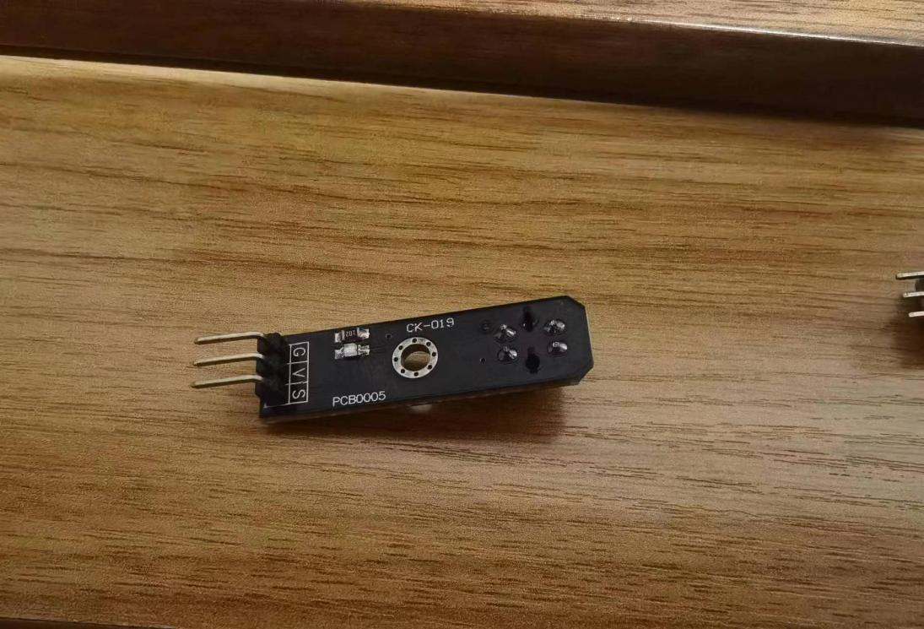

***Figure 4***, Picture of Tracing Module CK-019, picture taken by Xiao, Yafu.

**Ultrasonic Sensor HC-SR04.** This sensor as shown on the right realizes the function of distance measuring. While connected to a 5V DC power supply, whenever the trigger pin receives a high voltage signal for more than 10us, it sends out ultrasonic signal and sets pin echo to 1. While it receives the echo of the signal, it sets pin echo to 0. Therefore, while provided with a PWM signal, it performs as described above for each high voltage period, the echo pin then outputs a PWM signal as well, whose duty cycle has a positive correlation to the distance between the obstacle and the car.

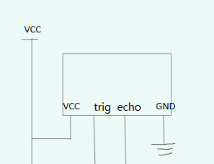

***Figure 5***, Schematic of Pins in the Ultrasonic Sensor, sketched by Ai, Liyi.

Ultrasonic sensors work based on the principle of sound waves, specifically ultrasonic waves, which are waves with frequencies higher than the upper limit of human hearing (typically above 20 kHz). Trigger provide a high voltage. Then, 40KHz acoustic burst is sent. Before receive the reflected signal, the echo pin keeps output high voltage.

### Design Consideration.

It is obvious that we need the rail tracing module to realize the rail tracing function. It is, though, a question why we chose the ultrasonic sensor instead of the TCRT5000 infrared emitter/detector. The latter is said to be only good for small distances from 1 to 2 cm. Since the car needed time to stop before crashing into obstacles, we chose to use the ultrasonic sensor for longer detecting distance.

## Design Description

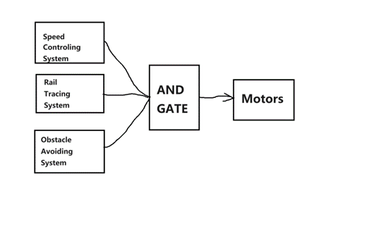

***Figure 6***, Block Diagram of the Car, illustrated by Xiao, Yafu.

This as shown above in figure 6 is a simple schematic diagram to show how our car works. In a gate, we put the tracking module, the ultrasonic module, and the speed regulation module of the motor together. As long as one side is wrong, the engine of the car will make certain adjustments.

The graph shown below in figure 7 is the overall schematic of the circuit of our design, which interpreted the three parts proposed in the block diagram.

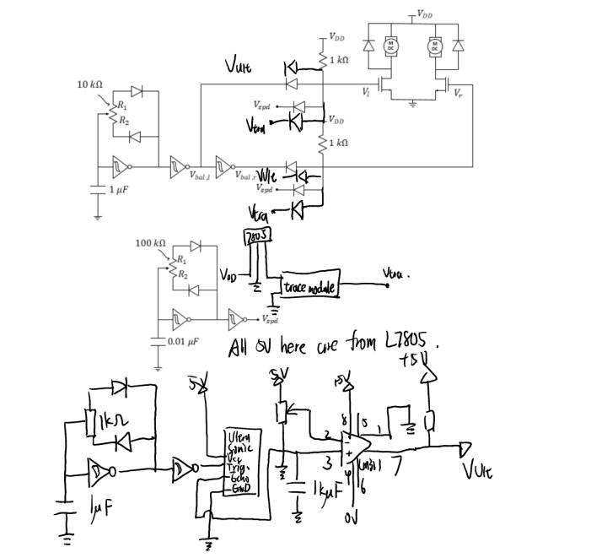

***Figure 7***, Overall Schematic of Our Circuit.

### Speed Control System

The system shown blow in figure 8 is the speed control system we inherited from previous labs, consisting of a balancing PWM signal and a speed controlling PWM signal. By using a potentiometer to control the duty cycle of the balance signal and inputting inverted balance signals to motors on each side, we are able to balance the speed of the two motors. The speed controlling PWM signal, however, inputs identical signal to both motors, leading a increase or decrease in spinning speed of both motors while been changed its duty cycle. This might seem confusing, so we’ve also added the o-scope graph of its output signal to clarify its working principle, as shown in figure 9 and figure 10.

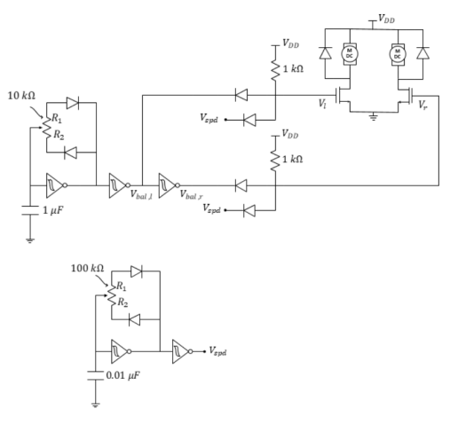

***Figure 8***, Speed Control System

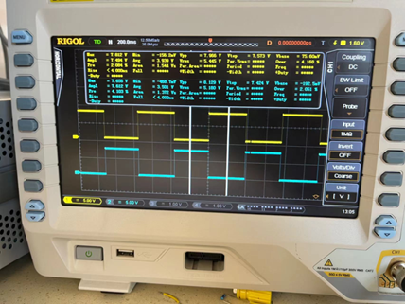

***Figure 9***, the Balancing Signal Waveform, Picture taken by Xiao, Yafu.

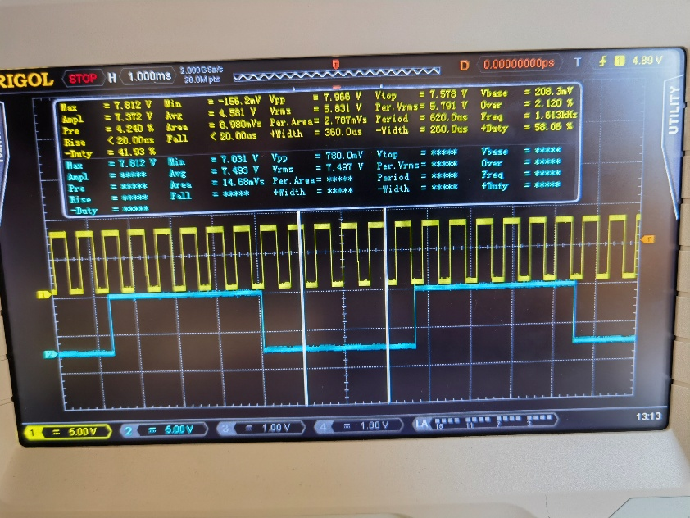

***Figure 10***, the Balancing Signal Waveform (Blue) and the Speed Controlling Signal (Yellow), Picture taken by Xiao, Yafu.

### Rail Tracing System

The picture shown in figure 11 is the rail tracing system of our car. The Vdd of the whole car is 7.6V while the operating voltage of the tracing module is 5V. We then used the L7805 Linear Voltage Regulator IC to lower the nodal voltage of the tracing module in order to make the module work properly. Since the module outputs VDD while detecting white and GND while detecting black and the rail to trace provided is black, we needn’t invert the output signal. We directly connect it to the MOSFET G node with a AND gate made up of diodes to ensure that the car is directly on the black rail.

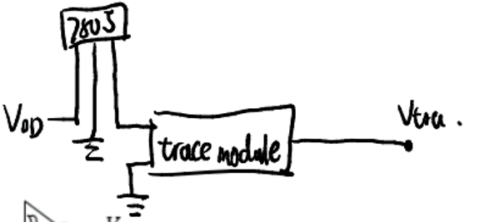

***Figure 11***, the Connecting Method of the Tracing Module, Sketched by Xiao, Yafu.

### Obstacle Avoiding System

Here, we choose to use the ultrasonic sensor, HC-SR04 to act as the obstacle detector. While receiving a high voltage on the trigger pin, it sends an ultrasonic signal and sets the echo pin to output Vdd, while receiving the echo of the signal, it sets the echo pin to output GND. The shorter the distance, the lower the duty cycle of the echo signal will be while having a PWM signal connected to the trigger pin. It is tested that a 1kHz PWM signal would be the best. Since the output echo signal is also PWM, we connect it to a 1 mF capacitor in parallel, which is connected to the ground. This acts a s a low-pass filter circuit, turning the PWM signal output to a DC voltage equivalent to its Vrms, this was then input into a voltage comparator, where we chose a voltage to decide at which length with the obstacle detected it stops. The schematic of the circuit is shown below in Figure 12.

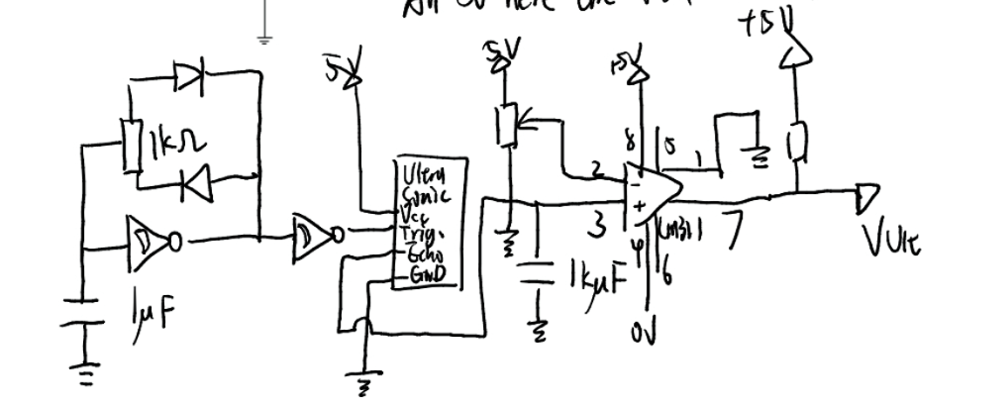

***Figure 12***, Schematic of the Obstacle Avoiding System, sketched by Xiao, Yafu.

## Conclusion

### Lessons Learn

We’ve encountered many unexpected difficulties while realizing our project. One significant difficulty is that the continuously unstable rail tracing sensors. It turned out that this is caused by the mistakenly connected 7V VCC, which is not in the range of 3.3-5V, the required operating voltage interval. This showed an inability in dealing with components with a different operating voltage, mainly caused by ignoring the details in datasheets, which should be wiped out in future experiments.

### Self-assessment

After all, given the astonishing ( at least to us) performance of the car, which showed every proposed feature in our design, I believe that I’ve done quite a good job in realizing the design. From proposals on the papers to real cars that acts good, we were forced to learn a lot and suffered a lot. This strengthened our understanding of the basic knowledge in circuit designing, and I surely benefited a lot.

**References**

*Datasheet-L78-Positive voltage regulator ICs*. (n.d.). Retrieved December 28, 2023, from https://www.st.com/resource/en/datasheet/l78.pdf